Fenobody and RANbody-Based Sandwich Enzyme-linked Immunosorbent Assay to Detect Newcastle Disease Virus

Pinpin Ji, Jiahong Zhu, Xiaoxuan Li, Wenqi Fan, Qianqian Liu, Kun Wang, Jiakai Zhao, Yani Sun, Baoyuan Liu, En-Min Zhou* and Qin Zhao*

Department of Preventive Veterinary Medicine, College of Veterinary Medicine, Northwest A&F University；Scientific Observing and Experimental Station of Veterinary Pharmacology and Diagnostic Technology, Ministry of Agriculture, Yangling, Shaanxi, 712100, China.

Table S1 Primer pairs for amplifying the VHH gene from the cDNA, identifying the positive clones by bacterial PCR, and amplifying fusion genes of fenobody. The underlying sequences in the primers were restriction sites for subsequently constructing recombinant plasmids.
Primer names | Sequences (5’-3’)
CALL001 | GTCCTGGCTGCTCTTCTACAAGG
CALL002 | GGTACGTGCTGTTGAACTGTTCC
VHH-FOR (Pst I) | CAGGTGCAGCTGCAGGAGTCTGGGGGAGR
VHH-REV (Not I) | CTAGTGCGGCCGCTGAGGAGACGGTGACCTGGGT
MP57 | TTATGCTTCCGGCTCGTATG
GIII | CCACAGACAGCCCTCATAG
NDV-2/4/24/30/49-FeNb –F (Nde I) | CCGCATATGATGCTGAGCGAACGCATGCTGA
NDV-2/4/24/30/49-Ferritin-R | ACTGCCTCCACCGCCACTGCCTCCACCGCCACTGCCTCCACCGCCGTCCTTGGCAAATTTCAGTTT
NDV-2/4/24/30/49-Nb-F | AAACTGAAATTTGCCAAGGACGGCGGTGGAGGCAGTGGCGGTGGAGGCAGTGGCGGTGGAGGCAGTCTGCAGGAGTCTGGGGGAGGCT
NDV-2/4/24/30/49-FeNb-R (BamH I) | GACGGATCCTTAGGCGGCCGCTGAGGAGACGGTGACC

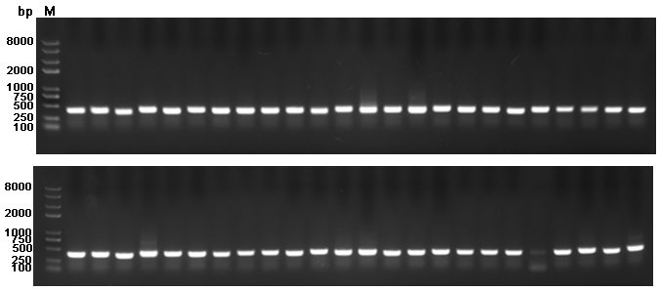

Fig. S1 Evaluate the positive rate of the VHH library by colony PCR.

